

**A Project Report**

**On**

**Efficient Bidirectional Wireless Power Transfer System Control Using Dual Phase Shift PWM Technique for Electric**

**Vehicle Applications**

***Submitted in partial fulfillment for the award of the degree of***

**Bachelor of Technology in**

**ELECTRICAL AND ELECTRONICS ENGINEERING**

***Submitted by***

**R. GANGA KARTHIK REDDY 224E5A0206**

**D. DEEPIKA 214E1A0202**

**B. ADI KESAVA REDDY 224E5A0201**

**K. PAVAN 224E5A0223**

***Under the esteemed guidance of***

**Mr. K. BABUM. Tech.,**

**Associate Professor, Dept. of E.E.E**

**DEPARTMENT OF ELECTRICAL AND ELECTRONICS ENGINEERING**

### SIDDARTHA INSTITUTE OF SCIENCE AND TECHNOLOGY

**(AUTONOMOUS)**

**( Approved by A.I.C.T.E., New Delhi Affiliated to J.N.T.U. Anantapur, Ananthapuramu.)**

**Siddharth Nagar, Narayanavanam Road, Puttur *–* 517 583,**

**2024-2025**



**(Approved by A.I.C.T.E., New Delhi Affiliated to J.N.T.U. Anantapur, Ananthapuramu.)**

**Siddharth Nagar, Narayanavanam Road, Puttur-517583**

### SIDDARTHA INSTITUTE OF SCIENCE AND TECHNOLOGY

**( AUTONOMOUS )**

**DEPARTMENT OF ELECTRICAL AND ELECTRONICS ENGINEERING**

Certificate

***This is to certify that the Project entitled***

**“Efficient Bidirectional Wireless Power Transfer System Control Using Dual Phase Shift PWM Technique for Electric Vehicle Applications”**

*that is being submitted by*

**R. GANGA KARTHIK REDDY 224E5A0206**

**D. DEEPIKA 214E1A0202**

**B. ADI KESAVA REDDY 224E5A0201**

**K. PAVAN 224E5A0223**

in partial fulfillment of the requirements for the award of **BACHELOR OF**

#### TECHNOLOGY in Electrical and Electronics Engineering to JNTUA,

**Ananthapuramu**. This project work or part thereof has not

been submitted to any other University or Institute for the award of any degree.

#### Guide Head of the Department

**Submitted for the University Examination held on**

**INTERNAL EXAMINER EXTERNAL EXAMINER**

Acknowledgement

An endeavor of a long period can be successful only with the advice of many well- wishers. We take the opportunity to express our deep gratitude and appreciation to all those who accouraged us for successful completion of the project work.

We wish to express my sincere thanks to **Dr. K. ASHOK RAJU garu,**

**Chairman** of Siddartha Institute of Science and Technology, Puttur, for providing ample facilities to complete the project work.

Our special thanks to **Dr. M. JANARDHANA RAJU garu, Principal,**

Siddartha Institute of Science and Technology, Puttur, for his wonderful support during the progress of project work.

We are very much thankful to Head of the Department, **Dr. N. BALAVENKATA MUNI, professor,** in department of *Electrical and Electronics Engineering,* Siddartha Institute of Science and Technology, Puttur, for his valuable suggestions in completion of the

project work.

We owe our deep gratitude to our project guide, **Mr. K. BABU, Associate professor,** Department of Electrical and Electronics Engineering, Siddartha Institute of Science and technology. Puttur., who took keen interest on our project work and guided us all along, till the completion of our project work by providing all the necessary. information for developing a good system.

Finally, we would like to express sincere thanks to **Departmental Review Committee (D.R.C)** members, faculty members of our department and Lab technicians, one and all who have helped us to complete the project work successfully.

We dedicate this work wholeheartedly as a sign of respect to our family members, friends, and their unwavering support.

## DECLARATION

We here by declare that the project report " **Efficient Bidirectional Wireless Power Transfer System Control Using Dual Phase Shift PWM Technique for Electric Vehicle Applications** " is a genuine project work carried by us, in bachelor of Technology in Electrical and Electronics Engineering by Jawaharlal Nehru Technological University Anantapur is a bonafide record work done at **SIDDARTHA INSTITUTE OF SCIENCE AND TECHNOLOGY** and has not been

submitted to any other courses or university for the award of any degree

BY

R. GANGA KARTHIK REDDY 224E5A0206

D. DEEPIKA 214E1A0202

B. ADI KESAVA REDDY 224E5A0201

K. PAVAN 224E5A0223

### ABSTRACT

This paper presents an enhanced bidirectional wireless power transfer (BWPT) system for electric vehicle (EV) applications, utilizing Particle Swarm Optimization (PSO)based Sliding Mode Control (SMC) with Phase Shift Modulation (PSM) for superior performance. The BWPT system enables seamless Grid-to-Vehicle (G2V) and Vehicle-to-Grid (V2G) operations, addressing key challenges such as power factor management, dynamic efficiency, and power transfer rates. While conventional dual-phase shift Pulse Width Modulation (PWM) techniques improve power factor correction (PFC) in unidirectional wireless power transfer (WPT) systems, bidirectional systems demand advanced control strategies to manage dual-side power converters effectively. The proposed PSO-SMC control framework optimizes the phase shift parameters, ensuring precise power flow regulation, enhanced stability, and reduced switching losses under varying load and grid conditions. Simulation results in MATLAB/Simulink demonstrate that the PSO-SMC with PSM significantly improves power factor, transfer efficiency, and overall system reliability, making it a robust solution for future EV charging infrastructure and smart grid integration.

**Keywords:** Bidirectional charging, electric vehicle, wireless power transfer, vehicle to grid, coil structure, bidirectional DC/DC converters, smart charging, SMC.

**INTRODUCTION**

* 1. INTRODUCTION TO PROJECT
  2. INTRODUCTION TO ELECTRIC VEHICLES

**EXISTING METHOD**

* 1. EXISTING METHOD
  2. DRAW BACKS

**PROPOSED METHOD**

* 1. PROPOSED METHOD
  2. ELECTRIC VEHICLES

**COMPONENTS**

* 1. DC MICRO GRID

4.2INVERTERS

4.3RECTIFIERS

4.4PARTICLE SWARM OPTIMIZATION(PSO)

4.5SLIDING MODE CONTROLLER

**SOFTWARE AND HARDWARE CONFIGURATION**

5.1 SOFTWARE CONFIGURATION

5.2 HARDWARE CONFIGURATION

**RESULTS**

6.1 OUTPUT

6.2 ADVANTAGES

6.3 APPLICATIONS

**CONCLUSION**

7.1CONCLUSION

7.2 REFERENCES

|  |  |  |
| --- | --- | --- |
| FIGURES NO. | TITLE | PAGES NO. |
| 1.1 | Illustration of wirelessly interconnected EVs in the V2G and G2V services | 9 |
| 1.2 | Electric vehicle | 13 |
| 1.3 | DC micro grid | 19 |
| 2 | BWPT System for the operation of (V Grid)  Side to (V Batt) side | 30 |
| 3 | BWPT system for the operation of (V Batt) side to (V Grid) side | 32 |
| 4 | Equivalent circuit of presented BWPT operation in mode 1 | 33 |
| 5 | Equivalent circuit of presented BWPT operation in mode 2 | 34 |
| 6 | Equivalent circuit of presented BWPT operation in mode 3 | 35 |
| 7 | Equivalent circuit of presented BWPT operation in mode 4 | 36 |
|  |  |  |
|  |  |  |

## CHAPTER-1

### INTRODUCTION

**1.1 INTRODUCTION:**

The automotive industry is significantly impacted by the advent of new energy challenges that are fueled by environmental concerns and the depletion of fossil fuels. This effect has prompted more study and advancement in the field of EVs [1]. One of the most important issues that needs to be resolved to enhance industry growth is EV recharging. The main difficulties with EV charging are recharge time, safety, and human interaction. To overcome these issues, the newly developed WPT technology is essential since it transfers power from a source to a load without physical contact [2]. In contrast to conventional cable charging, WPT offers the customer far greater comfort and security. With the use of this technology, charging is now safer and more convenient as there is no need for charging wires. Users may charge their devices anywhere there is a charging outlet thanks to human intervention-free charging features, which also minimize the size and weight of batteries and charging intervals [3]. Furthermore, WPT technology finds uses in high-power applications like as underwater vehicles, railway traction, and wireless energizing of implanted devices in the medical field [4], [5]. It is not limited to EV charging. WPT is significant because it can get beyond the limitations of battery-powered devices, such as short battery life and expensive starting expenditures. The characteristics of WPT, including its dependability, convenience, safety, and resilience to weather, have increased its appeal [6]. Specifically, it is expected that the use of BWPT will accelerate advancements in V2H, V2V, and V2G technologies, allowing electricity to flow both ways. For highfrequency operation, fully controlled switching components, such as SIC

MOSFETs and IGBTs, are incorporated into the design of the WPT/BWPT systems for both the primary and secondary bridges. The usual block diagram showing how photovoltaic (PV) systems, wirelessly connected EVs, a DC bus, and the power grid interact in V2G and G2V operations is shown in Figure 1. EVs contribute to the power grid by providing active or reactive power compensation capabilities, enhancing power quality and grid stability [7]. The integration of Renewable Energy Systems (RES), EVs, and the power grid can effectively increase RES penetration [8]. However, this integration requires constant bidirectional communication during charging and discharging condition.

##### FIGURE 1.1. Illustration of wirelessly interconnected EVs in the V2G and G2V service.

The grid-connected system also needs to maintain the THD and the power factor within the allowable range. Also, the power electronic converters used in the wireless charging system play a crucial role in maintaining the power quality. In the WPT system, different uncertain scenarios such as misalignment, parameter detuning, coil distance variation, and load variation introduce deviation from the normal operation of the system [9]. It also brings soft switching loss, power factor

reduction, component stress, and power transfer efficiency reduction. Nevertheless, the power factor is more important for the BWPT system to maintain the grid integration. Hence, maintaining a higher power factor is very important for the wireless charger design. On the other hand, the power transfer efficiency can be improved by using suitable resonant compensation networks at the primary and secondary [10]. Various compensation topologies are proposed for the unidirectional system to maintain the voltage and current variation. The two bridges’ AC links usually have compensating tanks added to them to increase system transmission capacity and efficiency. Attention has been drawn to the LCCBWPT system because of its symmetrical structure and less sensitivity to load change and coupling coefficient [11]. The LCC compensation architecture is used to alleviate problems resulting from S compensation on the primary side [12]. Through the utilization of an inverter to transform a voltage source into a current source, the LCC resonance compensation circuit on the primary side ensures a consistent current in the primary coil, preventing overcurrent concerns associated with S compensation. Additionally, even under light loads, the LCC resonance correction circuits contribute to the elevation of the output voltage. The relative phase angle and amplitude of the voltages produced by full-bridge inverters on the main and secondary sides control the power flow direction as well as the magnitude of both real and reactive power flows in classic BWPT [13]. Wireless communication interfaces can be used to synchronize the switching signals of these inverters, however doing so lowers system robustness and raises system expenses. An alternate control technique described obviates the necessity for wireless communication by synchronizing using the active and reactive power of the secondary side’s full- bridge inverter [14], [15]. The Real and reactive power flows are still determined by the passive elements’ characteristics as well as the relative phase angle and voltage magnitude from the full- bridge inverters on both sides. Recent advancements have shifted from single-sided to double-sided compensation in wireless circuit designs, providing greater flexibility and meeting WPT system design criteria [15]

For WPT systems operating at higher frequencies, especially in charging EV batteries, power

regulation from unregulated AC output to regulated DC output is crucial. In this context, Integrated

Power Factor Correction (PFC) circuits have been proposed to enhance system power density, replacing traditional front-end PFC circuits that often require cumbersome passive components [16]. Despite the potential impact on battery life, the integration of EVs with other resources is anticipated to be financially advantageous for both grid operators and EV owners. To enhance overall system cost-effectiveness, Power Factor Correction (PFC) has been implemented on the secondary side of a WPT system [17]. However, it’s crucial to acknowledge that this approach introduces increased circuit complexity [2]. The control strategy introduced for the secondary side of a WPT system employing an LCCL network underscores the significance of the LCCL compensation topology in maintaining a stable output voltage on the secondary side. Similarly, the stability is crucial for efficiently governing the connected DC–DC converter responsible for battery charging [3]. To manage the output voltage in a WPT system, a hybrid Inductor Capacitor- Capacitor-Series (LCC-S) compensated approach is employed [18]. By combining phase shift modulation and switch-controlled capacitor, this technique known as the LCC-S compensated WPT allows for wide-range output voltage regulation across the complete voltage range [4], [18], and [19]. For validation purposes, a 500-W prototype with a 400-V input voltage and a 100-250-V output voltage was assembled. Experimental data show that the converter maintains Zero Voltage Switching (ZVS) over the voltage range and reaches a maximum efficiency of 94.1% [19]. A detailed analysis of a dual-side LCC-LCC compensated WPT converter was done to obtain load independent Constant Voltage (CV) and Constant Current (CC) outputs at two distinct sites of zero- phase angular frequencies [5]. This analysis offered a methodical approach to design. Weight and volume are reduced with this technology in comparison to typical WPT topologies. The method streamlines its control system by enabling CC and CV power transfer modes through the use of contemporary Analog Phase Control (APC) and Digital Phase Control (DPC) techniques [6], [7]. A combination of simulation analysis and experimental data has been used to verify the accuracy of this novel approach. Examining secondary active converters as a means of controlling power transfer in WPT systems demonstrates that traditional WPT circuits frequently employ a front-end PFC interface, resulting in sizable passive components that have a substantial effect on system

dependability, losses, and volume. Because there are no intermediary storage elements on the primary side, phase shifts between the primary and secondary bridges are usually calculated using sophisticated synchronization techniques [7]. A new phase-shift control system was devised for a Full-Bridge Active Rectifier (F-BAR) functioning in Bidirectional Wireless Power Transfer (BWPT). This required modifications to the conventional receiver-side rectifier design. Theoretical and simulation findings show how this innovative control technique permits output value control without requiring a connection between the transmitter and receiver. Supplying the input voltage of 325V DC, an output power range of 0 to 3.7 kW, and a maximum efficiency of 94.4% is achieved. The experimental validation verifies the effectiveness of the converter and proposed control technique. The major contributions of the paper are

* The dual-side phase shift-controlled techniques control the power flow as well as improve the power factor.
* The performance analysis such as frequency bifurcation, power loss, and THD of proposed techniques for the BWPT system.
* The simulation and experimental validation of the dual side phase shift control technique for the BWPT system. Section II outlines different modes of operation in BWPT, while Section III delves into various control techniques for BWPT, emphasizing phase shift control. Section IV delineates the modes of bidirectional power flow control between V2G and G2V.

## CHAPTER-2

## EXISTING METHOD

**3.1 INTRODUCTION:**

* Traditional single-phase shift PWM control techniques are widely used but often suffer from limited efficiency under variable load and coupling conditions.
* Resonant wireless power transfer systems focus on reducing energy losses but struggle with effective bidirectional power flow control.
* Voltage-fed and current-fed inverter topologies are employed, but they face challenges in maintaining stability and reducing harmonic distortion.
* Adaptive control methods aim to address coil misalignment but lack the precision needed for efficient bidirectional operation

## 3.2. DRAWBACKS:

* Efficiency Issues: this is particularly Critical in Ev applications
* Limited Bidirectional capability: Many WPT systems are designed for Uni directional power transfer

## CHAPTER-3

**ELECTRIC VEHICLES**

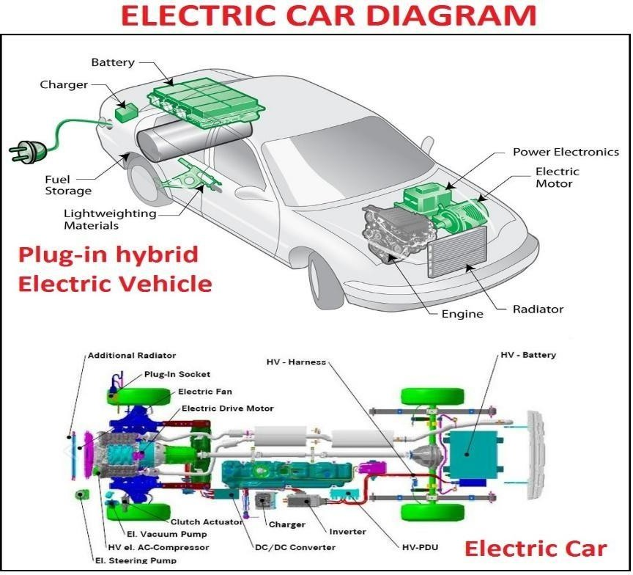

*Fig 1.2. Electric Vehicle*

**INTRODUCTION**

Electric vehicles (EVs) have a surprisingly long history that dates back to the early 19th century. The first electric vehicle was invented by Scottish inventor Robert Anderson in 1832, which used non-rechargeable primary cells. However, the first practical electric vehicle was not developed until the late 1800s.

In 1884, Thomas Parker, a British inventor, built the first practical electric car, which used lead-acid batteries and had a range of about 48 Kilometers .By the turn of the century, electric cars were becoming increasingly popular, particularly in urban areas, as they were quiet, easy to operate, and did not produce exhaust emissions.

However, the invention of the gasoline-powered internal combustion engine and the mass production of automobiles by companies such as Ford quickly made gasoline-powered cars more affordable and popular. As a result, the popularity of electric cars declined, and they became a niche product.

In the 1970s, the oil crisis led to renewed interest in electric vehicles as a way to reduce reliance on imported oil. This led to the development of several new electric cars, including the General Motors EV1, which was introduced in the 1990s.

In the 2000s, advances in battery technology and the need to reduce greenhouse gas emissions from transportation led to a renewed interest in electric vehicles. Companies such as Tesla, Nissan, and General Motors began to produce modern electric cars with longer ranges and better performance.

Today, Electric cars are gaining more popularity and becoming more widespread, as numerous nations worldwide establish goals to eliminate petrol-fueled vehicles in the forthcoming years. The history of electric vehicles shows that while their popularity has waxed and waned over the years, they have the potential to be an important part of the transition to a more sustainable and low-carbon transportation system

#### What is the need of EVs?

Electric vehicles (EVs) are needed for several reasons:

**Environmental concerns:** EVs have the potential to reduce greenhouse gas emissions and improve air quality. They produce zero emissions at the tailpipe, which can help reduce the harmful effects of air pollution on human health and the environment.

**Energy security:** EVs can help reduce a country's dependence on foreign oil and increase energy security by using domestically-produced electricity.

**Economic benefits:** The production of EVs can create jobs in the manufacturing and supply chain sectors. Additionally, EVs have lower operating costs than traditional gasoline-powered vehicles, which can save consumers money in the long run.

**Technological innovation:** The development of EVs has spurred technological innovation in battery technology, charging infrastructure, and other related fields. This innovation can lead to new and improved products and services that benefit society as a whole.

Overall, EVs are an important tool for addressing climate change, improving air quality, enhancing energy security, and promoting economic development and technological innovation.

#### Working of EVs

Electric vehicles (EVs) operate using an electric motor and a rechargeable battery instead of an internal combustion engine. The battery stores electrical energy that powers the motor, which turns the wheels and propels the vehicle forward.

The process of powering an EV starts with plugging the vehicle into an electrical outlet or a charging station. The battery is charged using electricity from the grid, which is converted into direct current (DC) power and stored in the battery.

When the driver wants to move the vehicle, they activate the accelerator pedal. This sends a signal to the controller, which determines how much power to send from the battery to the motor. The motor then converts the electrical energy from the battery into mechanical energy, which turns the wheels and moves the vehicle forward.

As the vehicle moves, the battery gradually discharges, and the range of the vehicle decreases. When the battery level drops below a certain point, the driver needs to recharge the battery using a charging station or electrical outlet.

Regenerative braking is another important feature of many EVs. When the driver brakes, the motor acts as a generator and converts some of the vehicle's kinetic energy back into electrical energy,

which is then used to recharge the battery. This helps to extend the range of the vehicle and improve overall energy efficiency.

#### Types of EVs

Electric vehicles (EVs) are vehicles that are powered by electric motors and batteries rather than by internal combustion engines that burn fossil fuels. There are several different types of EVs, including:

**Battery Electric Vehicles (BEVs):** These vehicles are powered solely by electricity and have no internal combustion engine. They are charged by plugging them into an external power source, such as an EV charging station, and can travel for hundreds of kilometers on a single charge.

**Hybrid Electric Vehicles (HEVs):** These automobiles are equipped with both an electric motor and an internal combustion engine that runs on gasoline. The electric motor provides assistance to the engine during acceleration and at lower speeds, resulting in improved fuel efficiency and reduced emissions.

**Plug-in Hybrid Electric Vehicles (PHEVs):** These vehicles are similar to HEVs, but they have larger batteries that can be charged by plugging them into an external power source. They can travel for a short distance on electric power alone before the engine takes over.

**Fuel Cell Electric Vehicles (FCEVs):** These automobiles employ hydrogen fuel cells to generate electricity that drives their electric motors. They produce no emissions other than water vapor.

Electric vehicles offer several advantages over traditional gasoline-powered vehicles, including: **Zero tailpipe emissions:** EVs produce no exhaust emissions, making them much cleaner and less polluting than gasoline-powered vehicles.

**Lower operating costs:** Electric motors are more efficient than internal combustion engines, meaning that EVs are cheaper to operate and maintain.

**Reduced dependence on oil:** Electric vehicles can be powered by a variety of sources, including renewable energy sources like solar and wind power, reducing dependence on oil and other fossil fuels.

**Quiet and smooth:** Electric motors produce very little noise and vibration, making EVs quieter and smoother to drive than traditional vehicles.

**Performance benefits:** Electric motors provide instant torque, meaning that EVs can be very quick and responsive, and can offer a smooth and enjoyable driving experience.

Overall, electric vehicles are becoming an increasingly popular and important part of the transition to a more sustainable and low-carbon transportation system

### ADVANTAGES

Electric vehicles (EVs) offer several advantages over traditional gasoline-powered vehicles, including:

**Zero tailpipe emissions:** EVs produce no exhaust emissions, making them much cleaner and less polluting than gasoline-powered vehicles. This can help to improve air quality and reduce the impact of transportation on public health and the environment.

**Lower operating costs:** Electric motors are more efficient than internal combustion engines, meaning that EVs are cheaper to operate and maintain. EVs also have fewer moving parts, which can reduce the need for maintenance and repairs.

**Reduced dependence on oil:** Electric vehicles can be powered by a variety of sources, including RES like solar and wind power, reducing dependence on oil and other fossil fuels. This can help to improve energy security and reduce the risk of price volatility associated with oil.

**Quiet and smooth:** Electric motors produce very little noise and vibration, making EVs quieter and smoother to drive than traditional vehicles. This can provide a more enjoyable driving experience and reduce noise pollution in urban areas.

**Performance benefits:** Electric motors provide instant torque, meaning that EVs can be very quick and responsive, and can offer a smooth and enjoyable driving experience. EVs can also be designed with a low center of gravity, which can improve handling and stability.

**Cost savings:** In many cases, EVs can provide significant cost savings over the lifetime of the vehicle. Although they may have a higher purchase price.

### APPLICATIONS

Electric vehicles (EVs) have several applications and benefits, including:

**Personal transportation**: Electric cars, trucks, and motorcycles are increasingly being used as a primary means of transportation for individuals and families. EVs offer a more sustainable and environmentally friendly option compared to traditional gasoline-powered vehicles.

**Public transportation:** Many cities are adopting electric buses and trains as a way to reduce emissions and improve air quality. EVs can also provide a quieter and more comfortable ride for passengers.

**Commercial transportation:** Electric trucks and vans are becoming more common in commercial fleets, especially for last-mile delivery and urban transportation. Electric vehicles can offer lower operating costs and reduced maintenance needs, making them an attractive option for businesses. **Renewable energy integration:** EVs can serve as a means of storing excess RES like wind and solar power. This helps to balance the grid and ensure a reliable supply of energy.

**Emergency services:** Electric vehicles are being used by emergency services like police, fire, and ambulance services. EVs offer fast and quiet response times, making them well-suited for urban environments.

**Agriculture and mining:** Electric tractors and mining equipment are becoming more common in these industries, offering a quieter and more sustainable option compared to traditional diesel- powered equipment.

Overall, the applications of EVs are diverse and offer a range of benefits, including reduced emissions, lower operating costs, and improved energy security.

**COMPONENTS**

**DC MICROGRID**

**WHAT IS DC MICROGRID**

## CHAPTER - 4

**PROPOSED METHOD**

A DC microgrid is an electrical distribution system that operates primarily on DC (direct current) power. In a DC microgrid, power is generated and distributed at low voltage levels in DC form, which can then be used to power local DC loads directly, or be converted to AC (alternating current) for use by AC loads.

DC microgrids are designed to operate autonomously, or connected to a larger grid, and can incorporate a range of distributed energy resources (DERs) such as solar photovoltaic panels, wind turbines, and energy storage systems. They can also incorporate DC-DC converters, DCAC inverters, and other power electronics to manage and optimize power flows within the system.

DC microgrids offer several advantages over traditional AC distribution systems, including higher energy efficiency, reduced power losses, and improved reliability and resilience. They are particularly well-suited for applications such as data centers, remote communities, military bases, and other locations where the use of renewable energy sources is desirable, and where the need for local power generation and storage is important.

### WORKING

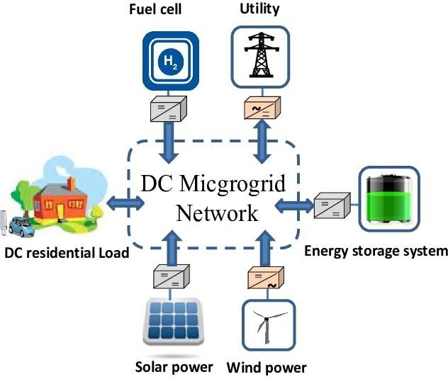

Fig 1.3. DC microgrid

The working of a DC microgrid involves several key components and processes:

**Power Generation:** DC microgrids can incorporate a variety of distributed energy resources (DERs) such as solar panels, wind turbines, and energy storage systems to generate power. These sources produce DC power directly, which can be used to power local DC loads directly or be converted to AC for use by AC loads.

**Power Distribution:** The generated DC power is distributed through a low voltage DC distribution network to the various loads connected to the microgrid. The distribution network can include DC- DC converters and other power electronics to manage and optimize power flows within the system. **Load Management:** DC microgrids can be designed to operate autonomously, or connected to a larger grid. In autonomous mode, the microgrid uses load management strategies to balance power supply and demand, and to prioritize power delivery to critical loads during periods of peak demand or when energy supply is limited.

**Energy Storage:** DC microgrids can incorporate energy storage systems such as batteries or capacitors to store excess energy generated during periods of low demand or when renewable energy sources are producing more energy than needed. This stored energy can then be used to power local loads during periods of high demand or when renewable energy sources are not producing enough energy.

.

### ADVANTAGES

DC microgrids offer several advantages over traditional AC distribution systems, including:

**Higher Energy Efficiency:** DC microgrids can be more efficient than AC systems because they eliminate the need for multiple DC-AC conversions, which can result in energy losses. By using DC power directly, DC microgrids can reduce these losses and improve overall energy efficiency. **Integration of Renewable Energy Sources:** DC microgrids can more easily integrate renewable energy sources such as solar panels and wind turbines, which produce DC power directly. This eliminates the need for DC-AC conversion and makes it easier to store and use the energy produced by these sources.

**Improved Power Quality:** DC microgrids can offer improved power quality, with less distortion and higher reliability than AC systems. This can be particularly important for sensitive equipment such as medical devices, data centers, and telecommunications equipment.

Overall, these advantages make DC microgrids particularly well-suited for applications such as data centers, military bases, remote communities, and other locations where the use of renewable energy sources is desirable and the need for local power generation and storage is important.

### DISADVANATGES

While DC microgrids offer several advantages over traditional AC distribution systems, there are also some potential disadvantages to consider:

**Limited Interoperability:** DC microgrids are not yet widely adopted and standardized, which can limit their interoperability with other systems and equipment. This can make it more difficult to integrate with existing infrastructure, and may require specialized equipment and expertise.

**Higher Initial Costs:** The initial capital costs of a DC microgrid may be higher than those of a traditional AC distribution system, particularly if specialized equipment is required.

### APPLICATIONS

DC microgrids can be used in a wide range of applications, including:

**Data Centers:** DC microgrids can be used to power data centers, which often use large amounts of DC power. They can improve energy efficiency, reduce energy costs, and provide backup power during outages.

**Military Bases:** DC microgrids can be used to power military bases and other installations, which often require reliable and resilient power. They can also provide power to remote locations and reduce the need for fuel shipments to these locations.

**Telecommunications:** DC microgrids can be used to power telecommunications equipment, which often requires DC power directly. They can improve energy efficiency and reduce energy costs.

**INVERTERS**

Inverters are electronic devices that convert DC (direct current) power into AC (alternating current) power. They are commonly used in a variety of applications where AC power is needed, but only DC power is available.

Inverters can be classified into two main types: pure sine wave inverters and modified sine wave inverters. Pure sine wave inverters produce a clean and stable output voltage that is very similar to the AC power supplied by the utility grid. Modified sine wave inverters, on the other hand, produce an output that approximates a sine wave but has some distortion.

Inverters can be used in a wide range of applications, such as solar power systems, backup power supplies, and RVs. They can also be used in cars and boats to power electronic devices. Some larger inverters can even be used to power entire homes or small businesses during power outages.

When choosing an inverter, it is important to consider the power rating, input voltage range, and output waveform. It is also important to ensure that the inverter is compatible with the devices that will be powered by it.

#### Advantages of inverters

Inverters have several advantages that make them popular in many applications. Here are some of the key advantages of inverters:

**Flexibility:** Inverters can convert DC power from various sources, including batteries, solar panels, and generators, into AC power. This flexibility allows them to be used in a wide range of applications, from backup power systems to renewable energy systems.

**Efficient Power Conversion:** Inverters are highly efficient and can convert DC power into AC power with minimal losses. This means that more of the available power is used to power devices, resulting in higher efficiency and lower operating costs.

**Clean Power Output:** Pure sine wave inverters produce a clean, stable output waveform that is similar to the power supplied by utility companies. This makes them ideal for powering sensitive electronic equipment that may be damaged by distorted or noisy waveforms.

#### 

#### Drawbacks of inverters

Although inverters have many advantages, they also have some drawbacks that should be considered when deciding whether to use them. Here are some of the main drawbacks of inverters:

**Cost:** Inverters can be expensive, especially pure sine wave inverters that produce a highquality output waveform suitable for sensitive electronic devices. This can be a barrier to entry for some applications, particularly in consumer electronics or smaller-scale applications.

**Efficiency:** Although inverters are generally highly efficient, they can experience some losses in the conversion process, which reduces overall system efficiency. This can lead to higher operating costs, especially for larger systems.

**Electromagnetic Interference:** Inverters can produce electromagnetic interference (EMI) that can interfere with other electronic devices. This can be a concern in some applications, especially where sensitive electronic equipment is being used.

#### Applications of inverters

Inverters are used in a wide range of applications, from consumer electronics to industrial and commercial applications. Here are some of the most common applications of inverters:

**Solar Power Systems:** Solar panels generate DC power, which needs to be converted into AC power for use in homes, businesses, or the power grid. Inverters are used in solar power systems to convert DC power into AC power

**Backup Power Supplies:** Backup power supplies, such as UPS (Uninterruptible Power Supply) units, use inverters to convert DC battery power into AC power during a power outage.

**Electric Vehicles:** Electric vehicles use inverters to convert DC power from the battery into AC power to drive the electric motor.

**Industrial Applications:** Inverters are used in industrial applications to convert DC power.

## RECTIFIER

#### What is rectifier?

A rectifier is an electronic device that converts alternating current (AC) to direct current (DC). AC is a type of electrical current that changes direction periodically, while DC flows in only one direction.

Rectifiers are commonly used in power supplies for electronic devices, where DC power is required for proper operation. The rectifier typically uses diodes, which are electronic components that allow current to flow in one direction but not in the other direction. When an AC voltage is applied to the diodes, they conduct current in one direction during the positive half-cycle of the AC signal, and in the opposite direction during the negative half-cycle. By using a combination of diodes, the AC signal can be converted to a DC signal.

There are different types of rectifiers, including half-wave rectifiers, full-wave rectifiers, and bridge rectifiers. The choice of rectifier depends on the specific application and the required voltage and current levels. Rectifiers are essential components in a wide range of electronic devices, including power supplies, motor drives, and battery chargers.

#### Working

The basic working principle of a rectifier is to convert alternating current (AC) to direct current (DC) by allowing current to flow in only one direction. This is done using a semiconductor device called a diode, which allows current to flow in one direction but not in the opposite direction.

In a simple half-wave rectifier circuit, the AC input voltage is applied to the anode of a diode, and the cathode of the diode is connected to a load resistor and a DC output voltage. During the positive half-cycle of the AC signal, the diode becomes forward-biased and conducts current in the forward direction, allowing current to flow through the load resistor and producing a positive voltage across the load. During the negative half-cycle of the AC signal, the diode becomes reverse-biased and does not conduct current, so no current flows through the load resistor and the voltage across the load is zero.

A full-wave rectifier circuit is more efficient than a half-wave rectifier, as it uses both the positive and negative half-cycles of the AC signal to produce a DC output voltage. This is achieved using a four-diode bridge rectifier circuit, which consists of four diodes arranged in a bridge configuration. The AC input voltage is applied to the two diagonally opposite terminals of the bridge, and the DC output voltage is taken from the remaining two terminals. During the positive half-cycle of the AC signal, the two diodes on the positive side of the bridge become forward-biased and conduct current, while the two diodes on the negative side of the bridge become reverse-biased and do not conduct current. During the negative half-cycle of the AC signal, the roles of the diodes are reversed, allowing current to flow through the load resistor in the opposite direction, producing a positive voltage across the load.

# Advantages

Rectifiers are electronic devices that are used to convert an alternating current (AC) to a direct current (DC). The advantages of rectifiers include:

**Efficient Power Conversion:** Rectifiers are highly efficient in converting AC to DC power, with minimal energy loss. This makes th+em ideal for use in a variety of electronic devices.

**Low Cost:** Rectifiers are relatively inexpensive to manufacture and easy to install. They require few components and are readily available in a variety of configurations.

**compact Size:** Rectifiers are typically small in size and can be easily integrated into electronic circuits without taking up too much space.

**High Reliability:** Rectifiers are very reliable and have a long lifespan, making them a popular choice for electronic devices that require consistent power supply.

# Drawbacks

Although rectifiers have many advantages, they also have some drawbacks, including:

**Ripple in Output Voltage:** Rectifiers can produce a DC voltage that is not completely smooth, but rather has a ripple effect caused by the AC input signal. This ripple can cause unwanted noise in electronic circuits.

**Nonlinear Load Characteristics:** The load on the rectifier may not be constant, and changes in the load can cause changes in the output voltage. This can cause issues in electronic devices that require a steady power supply.

**Inefficiency at Low Load Conditions:** Rectifiers may not operate efficiently at low load conditions, as the output voltage may be much higher than the load requires, resulting in wasted power.

# Applications

Rectifiers have many applications in various fields, including:

**Power Supplies:** Rectifiers are widely used in power supplies to convert AC power into DC power. They are used in electronic devices such as computers, televisions, and mobile phones.

**Battery Charging:** Rectifiers are used to charge batteries in electronic devices, such as laptops, smartphones, and electric vehicles.

**Motor Control:** Rectifiers are used in motor control circuits to convert AC power into DC power for the motors.

**Welding**: Rectifiers are used in welding machines to convert AC power into DC power for welding. **Electroplating:** Rectifiers are used in electroplating applications to convert AC power into DC power for the electroplating process.

**Particle Swarm Optimization (PSO):**

#### What is Particle Swarm Optimization Controller?

A PSO controller is an intelligent optimization algorithm that regulates system parameters by mimicking the social behavior of swarms.

##### Key Concepts:

* + Each particle represents a potential solution, such as a specific resistance, voltage, or torque. o Particles move within a search space, guided by their own experiences and the swarm's collective knowledge.

##### Components of PSO:

* + **Particles**: Represent candidate solutions in the optimization process.
  + **Fitness Function**: Evaluates how good a solution is (e.g., power output in MPPT).
  + **Velocity Update**: Determines the direction and speed of particle movement.
  + **Position Update**: Changes particle position based on velocity and fitness.

##### Core Principle:

* + PSO leverages cooperation and competition among particles to find the global best solution, balancing exploration (searching for new solutions) and exploitation (refining known good solutions).

#### Advantages

##### Global Optimization:

* + Searches the entire solution space, reducing the likelihood of getting stuck in local optima.

##### Robust Performance:

* + Adapts to changing conditions like varying solar irradiance and wind speeds, making it ideal for dynamic environments.

##### No Need for Detailed Models:

* + Works efficiently without requiring an explicit mathematical model of the system.

##### Efficient Convergence:

* + Quickly finds optimal solutions, suitable for real-time applications.

##### Flexibility:

* + Easily configurable for different systems, such as solar PV, wind turbines, or electric vehicles.

#### Drawbacks

##### Parameter Sensitivity:

* + Performance depends on proper tuning of parameters like inertia weight, acceleration coefficients, and swarm size.

##### Computational Complexity:

* + Real-time applications may require high computational power for large swarms or complex fitness functions.

##### Premature Convergence:

* + Without careful parameter tuning, particles may converge too early to a suboptimal solution.

##### Resource Intensive:

* + Requires additional calibration and testing to achieve optimal performance in specific applications.

#### Applications

##### Solar Photovoltaic (PV) Systems:

* + Optimizes power output by accurately tracking the Maximum Power Point (MPP), even under partial shading or varying temperatures.

##### Wind Turbines:

Maximizes energy production by adjusting blade pitch and generator torque to match wind speeds.

##### Energy Storage Systems:

* + Enhances battery life and efficiency by managing charging and discharging cycles.

##### Electric Vehicles (EVs):

* + Improves range and energy usage by optimizing motor torque and battery current.

**Sliding mode controller:**

#### What is sliding mode controller

A sliding mode controller (SMC) is a type of control method used in nonlinear control systems. It is designed to regulate the system output by generating a sliding surface that forces the system trajectory to move towards a desired state, while also ensuring robustness in the presence of disturbances and uncertainties.

The basic idea of SMC is to create a switching function, which is a continuous function that changes sign whenever the system trajectory crosses a certain boundary, or sliding surface. The sliding surface acts as a barrier that keeps the system trajectory within a certain region, even in the presence of disturbances or uncertainties.

#### Working

Sliding mode control is a type of control technique that is used to achieve robust and accurate control of a system. It is based on the concept of sliding mode, which refers to a situation where the system states move along a predefined sliding manifold.

The working of a sliding mode controller can be summarized in the following steps:

**Design the sliding manifold:** The first step in designing a sliding mode controller is to define the sliding manifold. This manifold is a subspace of the state space that is designed to be invariant to uncertainties and disturbances. The design of the sliding manifold is critical to the performance of the sliding mode controller.

#### Advantages

Sliding mode control is a powerful control strategy that offers several advantages over traditional control techniques. Some of the key advantages of sliding mode control are:

**Robustness:** Sliding mode control is inherently robust to uncertainties and disturbances in the system. The sliding mode controller is designed to ensure that the system states stay on a predefined sliding manifold, which is robust to perturbations in the system.

**Nonlinearity:** Sliding mode control is effective for controlling highly nonlinear systems, which are difficult to control using traditional linear control methods. The sliding mode control law is nonlinear and discontinuous, which enables it to handle nonlinearities in the system.

**Fast response:** The sliding mode controller is designed to drive the system states towards the sliding manifold quickly. This results in a fast response time and better performance in transient conditions.

#### Disadvantages

Although sliding mode control has several advantages, it also has some limitations and disadvantages. Some of the key disadvantages of sliding mode control are:

**Chattering:** Sliding mode control can suffer from chattering, which is a high-frequency oscillation in the control signal. Chattering can cause excessive wear and tear on the control system and reduce the life of mechanical components.

**Complexity:** Although the design of the sliding mode controller is relatively simple, the analysis of the controller's stability and performance can be complex. The controller requires knowledge of the system dynamics and may require tuning of several control parameters.

#### Applications

Sliding mode control has a wide range of applications in various fields, including control engineering, aerospace engineering, robotics, and automotive engineering. Some of the common applications of sliding mode control are:

**Aerospace engineering:** Sliding mode control is used for the control of aircraft, satellites, and spacecraft. It is particularly useful for systems with large uncertainties and nonlinearities.

**Robotics:** Sliding mode control is used for the control of robots, including manipulators and mobile robots. It is effective for handling nonlinearity and disturbance rejection, making it suitable for robotic applications.

**Power systems:** Sliding mode control is used for the control of power systems, including renewable energy systems and power converters. It is particularly useful for systems with uncertain and time- varying parameters.

## BI DIRECTIONAL WIRELESS POWER TRANSFER SYSTEM

In the BWPT system, EVs are connected to the DC bus via the WPT charging system. Each side of the system consists of coupling coils, high-frequency converters, a compensation circuit, and controllers with specialized designs. Figures 2 and 3 illustrate the circuit diagram of the proposed topology during both charging and discharging conditions. During the transfer of energy from the grid to the EV in G2V Mode, the primary converter operates as a DC/AC inverter, while the secondary converter serves as a controlled rectifier for AC/DC conversion. Conversely, in V2G mode, when the EV battery transfers power to the grid, the roles of the converters are reversed [11]. The circuit comprises a primary side inverter with an LCC-based resonant converter and a secondary side converter. By adjusting the primary side voltage (VP) or secondary end voltage (VS) in this bidirectional control architecture by matching the duty cycles of the inverters the regulation is accomplished. Modulating the low-frequency signal average value of the primary side as well as secondary end voltages allows for power regulation. The system includes both primary and secondary compensation networks, as was previously described.

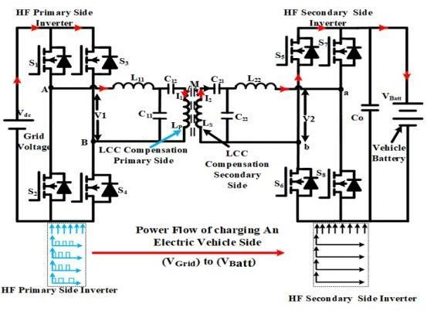

##### FIGURE 2. BWPT system for the Operation of (V Grid) Side to (V Batt) Side.

The exchange of energy from the primary coil to the secondary coil is made possible through the application of mutual induction principles, which take place during the resonance condition.

The controllers play a crucial role in overseeing the power transfer between the two coils throughout each operational phase. Phase shift control is commonly employed through an improved Pulse Width Modulation (PWM) technique, where control signals are directed to both sides of the converter switches. To implement bidirectional converters, fundamental approaches consider the dual functionality of both converters at primary and secondary parts. When transferring power from the grid to the battery,

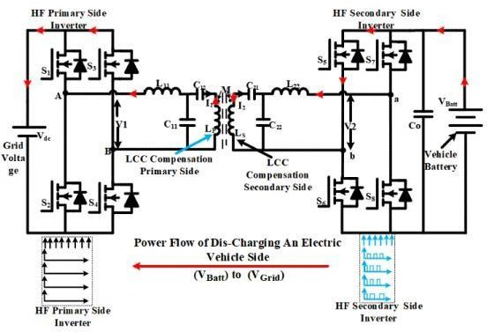

**FIGURE 3. BWPT system for the Operation of (VBatt) Side to (VGrid) Side**

Phase Shifting Modulation (PSM) techniques are employed to regulate the primary converter, while the secondary side converter functions as a rectifier simultaneously. Figure 2 illustrates this methodology. Likewise, during the transfer of power from the battery to the grid, the DC/AC converter on the secondary side operates as an inverter, while the AC/DC converter on the primary side functions as a rectifier. This is illustrated in Figure 3, depicting the discharge process. In this method, the active power flow is easily modifiable, and the anticipated efficiency is determined. To establish the configuration in both controllers, the power converters must work in conjunction. This is achieved by establishing a wireless communication channel, with signal processing delay not being a limiting factor. Thus, both controllers are readily configurable and synchronized.

**A.MODES OF OPERATION OF BWPT**

Mode I: (αto π)

During the time interval (αt to π), switches (S1) and (S4) are conducting on the primary side, allowing current to flow through (S1), compensating inductance (Lf1), series and parallel

capacitances (C1, Cf1), and the primary coil (L1). Simultaneously, switches (S4) are also part of this circuit. On the secondary side, switches (S7) and (S6) are active during the same period. The induced current flows through the secondary coil (L2), series and parallel capacitances (C2, Cf2), compensating inductance (Lf2), and the switches (S7) and (S6), eventually reaching the load.

The current flows in the forward direction across the load on the vehicle battery side. Figure 4 depicts the equivalent circuit of the described bidirectional power transfer system functioning in Mode I.

Mode II: (0≤t ≤ α) during the time interval (0 to α), the upper switches on the primary side, namely (S1) and (S3), are conducting. However, some dead time occurs due to the release of stored energy in the inductance, causing the current to circulate between these two switches, resulting in a zero- current state. Simultaneously, on the secondary side during the same period,

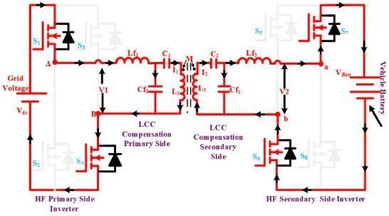

##### FIGURE 4. Equivalent circuit of presented BWPT operation in Mode I.

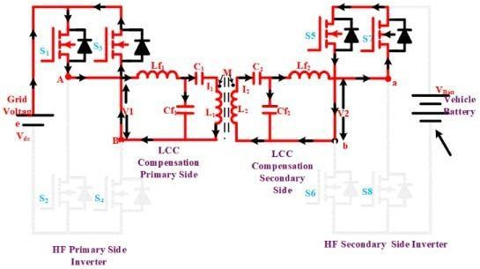

**FIGURE 5. Equivalent circuit of presented BWPT operation in Mode II.**

the upper switches (S5) and (S7) are conducting. Similar to the primary side, there exists a dead time when the stored energy in the inductance releases current, circulating between switches (S5) and (S7). As a result, the current through the load becomes zero [14]. Figure 5 provides a visual representation of the equivalent circuit of the presented bidirectional power transfer system in operation during Mode II.

Mode III: (π+α ≤ t≤2π):

During the time interval (π + αt to 2π), switches (S2) and (S3) are conducted on the primary side. The current (I) flows through switches (S2), compensating inductance (Lf1), series and parallel capacitance (C1, Cf1), the primary coil (L1), and the switches(S3). Simultaneously, on the secondary side during the same period, switches (S8) and (S5) are conducting. The induced current flows through the secondary coil (L2), series and parallel capacitance’s (C2, Cf2), compensating inductance (Lf2), and the switches (S8), the load, and the switches (S5), respectively. The current flows through the load on the vehicle battery side in a reversed direction. Figure 6 illustrates the Mode III equivalent circuit operation.

Mode IV:(π ≤ t≤ π+α) During the time interval (π to π + α), the lower switches on the primary side, namely (S2) and (S4), are conducting. However, some dead time occurs due to the release of stored energy in the inductance, leading to the circulation of current

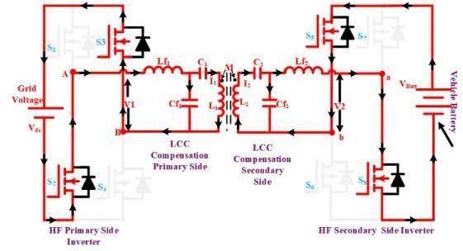

##### FIGURE 6. Equivalent circuit of presented BWPT operation in Mode III.

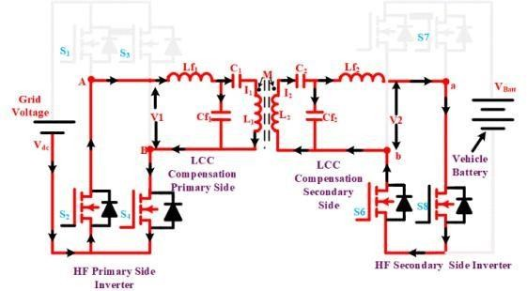

**FIGURE 7. Equivalent circuit of presented BWPT operation in Mode IV.**

between these two lower switches as a result, the current becomes zero. Simultaneously, during the same period on the secondary side, the two lower switches, (S6) and (S8), are conducting. Similar to the primary side, there is a dead time as the stored energy in the inductance releases current, circulating between switches (S5) and (S7), respectively. As a result, the current across the load becomes zero. Figure 7 illustrates the equivalent circuit of the presented bidirectional power

transfer system operating in Mode IV. Consequently, the switching waveforms for different modes of bidirectional wireless power transfer for V2G and G2V operations are illustrated in Figure 8.

1. **PHASE SHIFT CONTROL**

The parameter α, reliant on the reference signal, is crucial for enabling the primary side circuit to operate at the rated current of the secondary controller. It is employed to finely adjust the output voltage of the primary side inverter. Simultaneously, the secondary controller generates the phase shift (β) between the legs of the secondary inverter, influencing the relationship between both primary and secondary output voltages. Implementing the PWM technique involves utilizing low- level switching signals, which are subsequently interpreted for the left- and right-side by fine-tuning of phase shift parameters (α, β, and δ) [16]. To achieve the desired magnitude and direction of power flow, it becomes necessary to modify the secondary side control parameters (β and δ). The configuration of the four switches on both sides of the highfrequency converters is defined by signals enhanced by the driver circuits. These control parameters are crucial for attaining the desired power flow within the system, and adjusting the amplitude and phase of the inverter voltages [17].

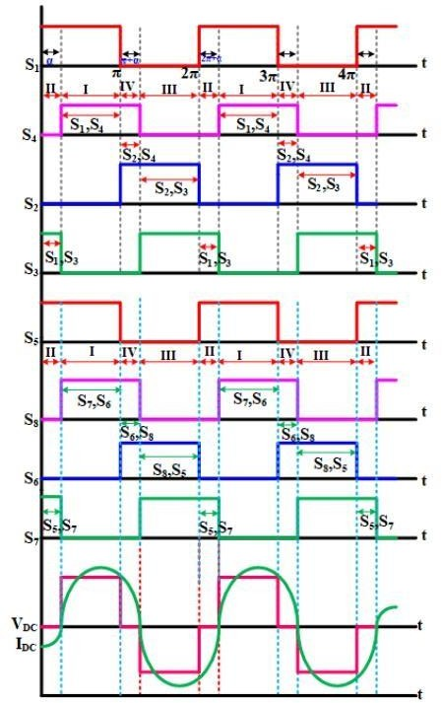

##### FIGURE 8. Switching waveforms of BWPT for V2G and G2V Operation.

In BWPT, each side can simultaneously function as both a supply and a load. Consequently, both sides must be treated similarly. Simultaneously engaging the full-bridge converters on both the primary and secondary sides involves a purposeful delay in activating semiconductor switches on both ends. The regulation of power flow between the primary and secondary converters (AC/DC and DC/AC) utilizes phase angles (α, β) and the delay angle (δ). Figure 9 visually represents the switching waveforms, illustrating the phase angle delay between the two converters. Typically, the phase shift angle modulates the power level on both sides. The delay angle (δ) indicates the phase

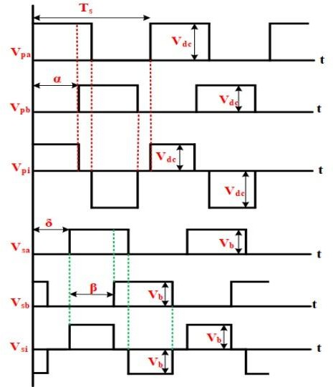displacement between the peak voltages of the primary and secondary inverters [18]. Both converters output voltage VP(t) and VS(t) for the first harmonics are expressed as

##### FIGURE 9. Switching waveforms of phase angle delay between the two converters.

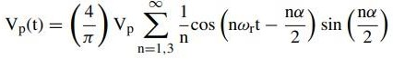 **1**

##### 2

where n represents the order of harmonics. In the above equation, α & β represent the phase shift between switches of an inverter pair, and similarly, VP and VS represent the primary and secondary side inverter peak voltages, and ‘n’ represents the harmonics orders.

1. **ESIGN PARAMETERS FOR THE BWPT SYSTEM**

Developing the phase shift controller with improved PFC control is essential for the design of BWPT systems. The power transfer between the primary and secondary coils can be expressed at the resonance frequency.

 **3**

The mutual inductance between the primary and secondary coils is denoted by M in this instance. The Root-Mean-Square (RMS) current passing through the primary and secondary coils is indicated by the letters IP and IS, respectively. In wireless charging systems, the mutual inductance between these coils is crucial since it directly affects the efficacy and efficiency of power transfer. In this particular scenario, the operating frequency of 85 kHz aligns with the SAE J2954 standard. Subsequently, the expression for the output power is as follows,

 **4**

where f0 represents the operating frequency. Both the primary and secondary coil turns are indicated by the letters NP and NS, respectively. For both the primary and secondary coils, the inductance per turn is denoted as Lˆ P and Lˆ S , respectively. The coupling coefficient between the coils is represented by K. If K is high, there will be a lower air gap, and vice versa when K is low. The air gap between the charging pads and their size determines the mutual inductance per turn given by the expressions

 **5**

The increased mutual inductance (M) results from larger pad diameters and reduced air gap [20]. The self-inductance of the ferrite core is nearly two times as compared to the air core, which increases the coupling coefficient (K) by 30%–50% [21]. Controlling the output power and ampere- turn ratio is essential to ensure that the receiver and transmitter pads are the same size. A 3D finite- element analysis (FEA) model with a lumped coil was created using the charging coil dimension

and air gap to calculate the coupling coefficient and inductance per turn. The ampere-turn design of the primary side and secondary side coils is still an important design element for the specified power rating, air gap, and size [22]. Compared to traditional series compensation, the LCC compensation offers additional design options for current and turn configurations. The LCC-LCC compensating circuit configuration of a connected coil is shown in Figure 2. The current IP and IS can be obtained using the following equation

 **6**

1. **POWER FACTOR CORRECTION IN THE BWPT SYSTEM**

In an ideal WPT system, Power Factor Correction (PFC) can be implemented either at the frontend or back-end. However, it’s crucial to consider that the decision between front-end and back-end PFC depends on various factors, including system requirements, efficiency considerations, and design constraints [25]. Each approach comes with its own set of advantages and disadvantages, and the selection should be made based on specific system needs. In an ideal WPT

##### TABLE 1. Electrical circuit parameters of 3.7 KW BWPT system.

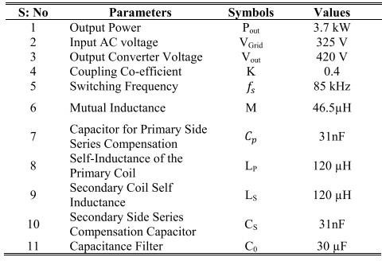

system, power transfer at the resonant frequency can be expressed as:

 16

The LM, which is computed using the coupling factor value, the separation between the primary and secondary coils, and the coil misalignment, can be used to calculate the interaction between self and mutual inductance. The letters LP and LS stand for the primary and secondary coils’ respective self-inductance. The region of 0.2 to 0.5 is where the K value varies the most. The resonance frequency remains unaffected by the load, and either VP or VS can be utilized to adjust the output power. The frequency spectrum outlined by the automotive SAE standard J2954 spans from 81.39 kHz to 90 kHz. The PFC model comprises active rectification, and LCC compensation coupled to an H-bridge converter on both the primary and secondary sides. Additionally, there is passive DC-DC control of the output interfaces for battery charge control. Assuming a correction of the unity power factor, it is considered that power in single-phase alternating current (AC) systems is proportional to the quadratic sine function.

 **17**

where Vg and Ig correspond to the input voltage and RMS current of the grid respectively. Under this condition, the switching frequency is not a control variable. As a result, power control is accomplished by regulating the average low-frequency primary voltage (Vpf) or secondary voltage (Vsf). This ensures PFC while accommodating a 100 Hz fluctuating power source. Hence, the transferred power can be calculated as follows

**18**

It is assumed in this study that continuous voltage (CV) and continuous current (CC) control work together to regulate batteries. We’ll use this control mechanism by battery current and voltage measurements. To help with CC management, a current saturation mechanism has also been included. Accurate current regulation becomes dependent on the internal current control loop, which efficiently offsets internal and external disturbances. Since the resonant current and the secondary-side voltage are always in line, the transmitted power can be computed as follows

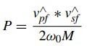 **19**

where the fundamental voltage amplitudes on the main and secondary sides at the switching frequency are denoted by Vˆ pf and Vˆ sf , respectively

 **20 ** **21**

where, δp and δs represent the primary and secondary duty cycles, respectively. Vr is the rectified grid voltage and VBAT is the battery voltage. Regardless of which converter performs PFC and current shaping, both PFC control strategies necessitate a grid-connected unfolding 50 Hz active rectifier. The resonant inverters control the primary resonant tank (VP) as well as transfer current between both the primary and secondary coils by manipulating unregulated (AC) voltage. Moreover, communication systems or estimation methods are necessary when the power control is managed by an off-board primary-side resonant inverter.

* 1. **PRIMARY SIDE PSM CONTROL**

Primary-side control (PSC) modifies the primary voltage (VP) to provide control over the battery charging process; the secondary voltage (VS) is left uncontrolled. To achieve this, a duty-cycle control approach utilizing Phase-Shift Modulation (PSM) is employed within the primary-side resonant inverter. In this setup, all switches are controlled by square modulation, and the phase difference between the two inverter branches regulates the duty cycle (δp). To reduce conduction losses on the secondary side, two operational modes are accessible: a passive converter or synchronization with the resonance current. In both cases, it is possible to generate a primary current with a constant magnitude. Both operation modes share a similar duty-cycle calculation approach, with the primary distinction lying in the pulse generation strategy. Furthermore, the pulse patterns for each switching device may vary according to their operational frequency, either line or the switching frequency. In both G2V and V2G operations, it is assumed that the primary coil current remains at a constant amplitude sinusoidal waveform. Consequently, the modulation of fluctuating power should be accomplished through control of the primary voltage. The fluctuating power can be obtained using the primary voltage. Utilizing equations (20) and (21), we can define the fundamental voltage reference as follows:

 **22**

where, V  p value substitute in the equation below,

******23**

Using Phase-Locked Loop (PLL) synchronization at the grid measurement system the cosine waveform can be obtained from the preceding equation (23) [22]. Similarly, the Magnitude to Voltage of the Battery Voltage (M/(VBAT)) is obtained with peak current measurement at the primary coil (24).

**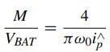****24**

From the steady-state measurements of the primary side, it is not easy to extricate M and VBAT separately, as the limits of both parameters are relatively large, and require alternate techniques for a precise VBAT estimation. Using equation (20), the duty cycle expression for the primary side can be calculated as follows

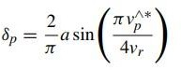 **25**

* 1. **SECONDARY SIDE PSM CONTROL**

The secondary rectifier’s duty cycle (PWM) is controlled by a Phase Shifted Pulse-Width Modulation (δs) in the secondary-side control approach. An unconstrained square-wave modulation can be used to produce a primary current with a changeable amplitude by modulating the voltage of the secondary side. The secondary coil current can be utilized for the PLL input in case of failure at the on-board system to measure grid voltage. To put it another way, the secondary voltage reference needs to meet these requirements:

 **26**

As obtaining both variables independently is difficult, the M/Vgrid value can be approximated using the secondary peak current values (24). It is possible to estimate the coupling factor based on a relatively narrow range of grid voltage amplitude in this case

 **27**

By integrating with equation (6), we can calculate the duty cycle from the secondary side with the equation as:

**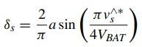****28**

Moreover, every switching device’s pulse patterns are provided and differentiated among switches to function as switching frequency fs and those that operate at line frequency [24], [25].

* 1. **PHASE SHIFT PWM TECHNIQUES FOR INVERTERS**

Phase-shift control proves effective for H-bridge converters, thanks to their remarkable efficiency, minimal electromagnetic interference (EMI), and the absence of voltage fluctuation concerns.

Generally, when aligning the converter switching angular frequency with the resonant tank’s angular resonance frequency, the PSM is formulated as follows,

 **29**

**CHAPTER-5**

**SOFTWARE-REQUIREMENTS**

* Software Configuration:
* Operating System: Windows 7/8/10
* Application Software: MATLAB / Simulink
* Hardware Configuration:
* RAM : 8 GB
* Processor : I3 / I5 (Mostly prefer)

## CHAPTER-6

**SIMULATION RESULTS**

**Case-1(V Grid) Side to (V Batt) Side**

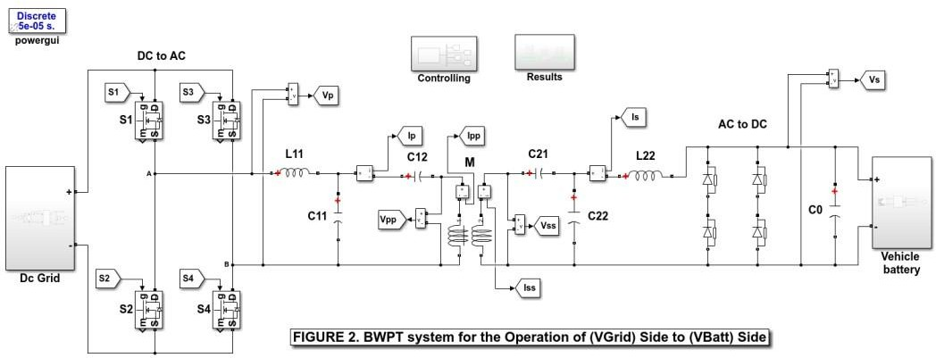

**Simulation model**

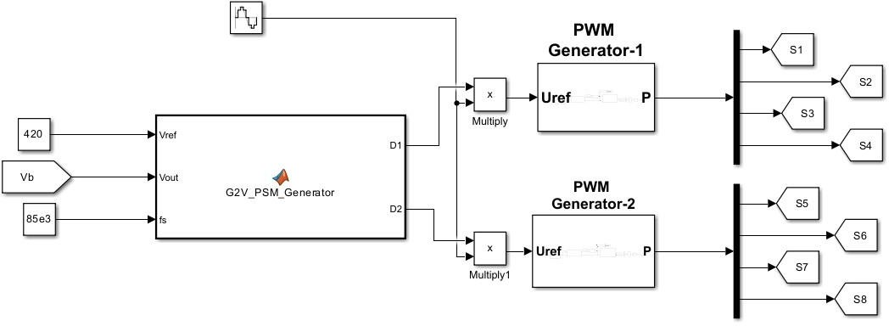

**Figure 2(c) Controlling Diagram with PSO SMC Controlled Phase shift Modulator**

The controlling diagram illustrates the PSO-SMC-based Phase Shift Modulator (PSM) for the proposed bidirectional wind power converter. This advanced modulator generates pulse signals for the primary and secondary bridges by processing the reference voltage (Vref) and the actual output voltage (Vout) through a combined Particle Swarm Optimization (PSO) and Sliding Mode Control (SMC) algorithm. The PSO dynamically optimizes control gains, while the SMC ensures robust and precise error correction. Together, they adapt the phase shifts and duty cycles to regulate bidirectional power flow efficiently, achieving reduced harmonic distortion, enhanced power factor, and optimized system performance in both Grid-to-Vehicle (G2V) and Vehicle-to-Grid (V2G) modes.

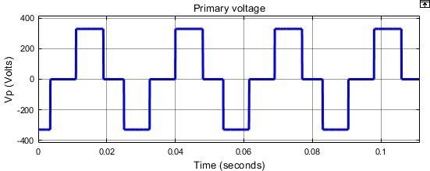

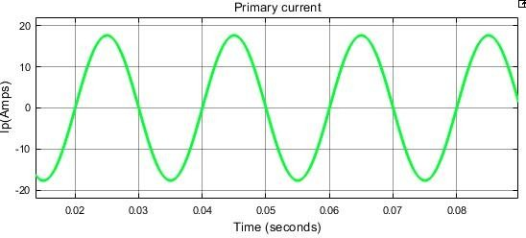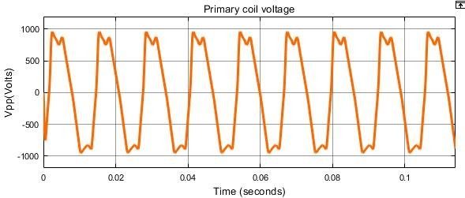

**FIGURE 16. (a)The Grid Input Voltage (b) Primary side Converter voltage control (Vpp)**

**Current (I pp) (c) Primary coil voltage (V pp) across the transmitter pads (V pp) (d) The Primary coil current across the transmitter pads (I pp).**

Initially, the G2V operating simulation mode is run first, considering the grid frequency of 50Hz and a magnitude of grid supply voltage 325V. Figure 16(a) shows the sinusoidal change of the nominal grid input voltages. The primary side converter voltage and current are illustrated in Figure

16(b). The primary coil current and the voltage plotted in Figure 16(c) and (d) show the presence of voltage harmonics. Meanwhile, on the primary coil side, the modulated voltage (Vpp) is close to 940 V, and the modulated current (Ipp) is 12A.

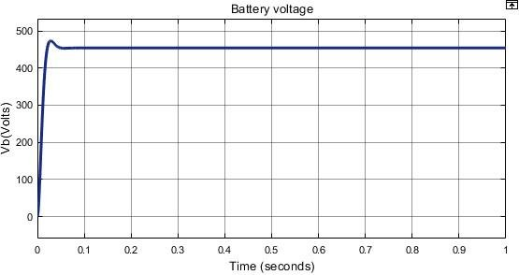

**Battery voltage**

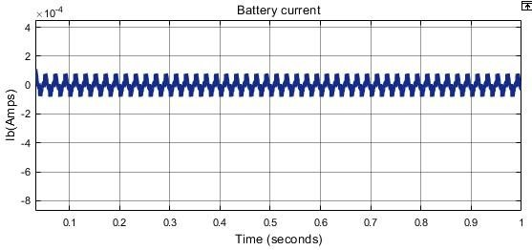

**Battery current**

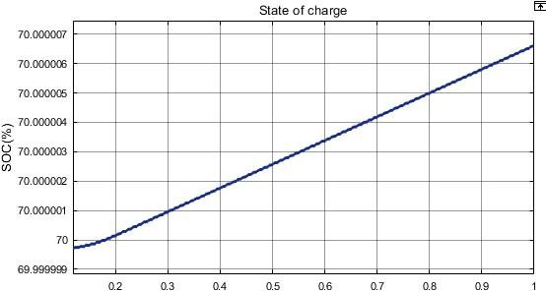

## SOC

**EV Battery voltage, current and state of charge**

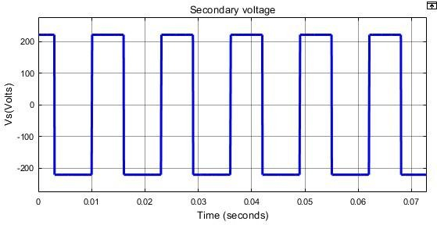

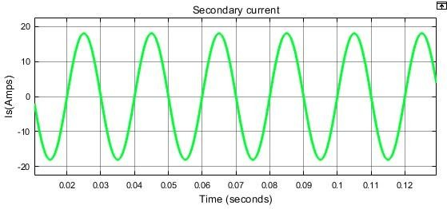

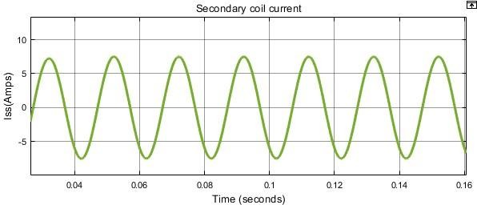

**Case-2_(V Batt) Side to (V Grid) Side**

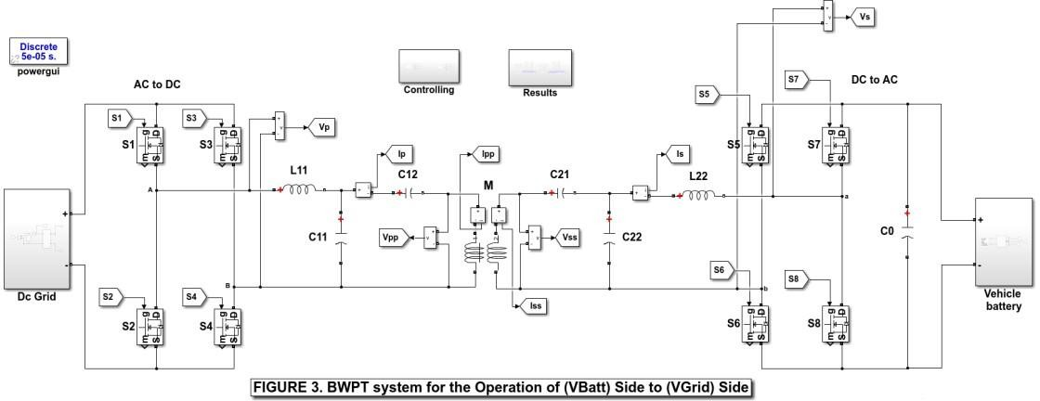

**Simulation model**

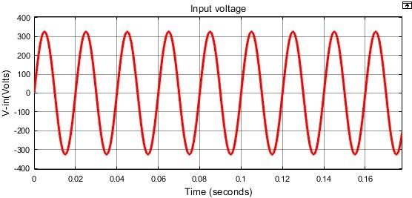

**Input voltage**

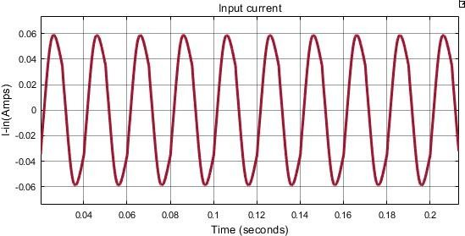

##### Input current

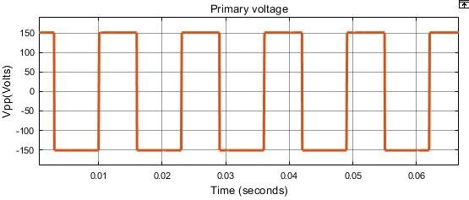

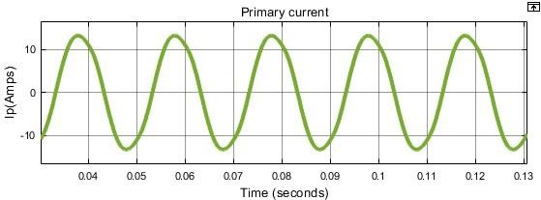

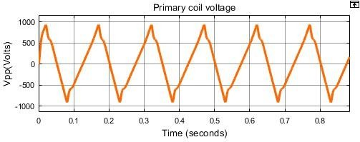

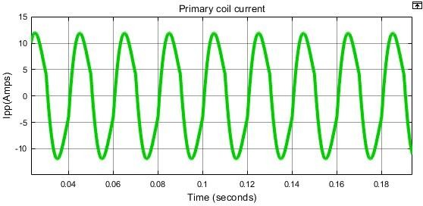

**FIGURE 18. (a) Converter voltage(V pp) Current (I pp) at the primary side (b) Voltage (V pp) across the primary pads (c) Primary coil Current (I pp).**

The V2G side of the simulation study is performed with control over the secondary converter and without modulating the primary side converter. The design parameters are followed the same as for the G2V operation except for the change in control flow. Figure 18(a) shows the primary side unregulated square-wave modulation converter voltage and current. The peak values of the primary side voltage (V pp) and primary current (I pp) are 150V and 10A, respectively. Meanwhile, Figures 18(b) and 18(c) show the sinusoidal current and fluctuating voltage derived from the primary side pad voltage and current.

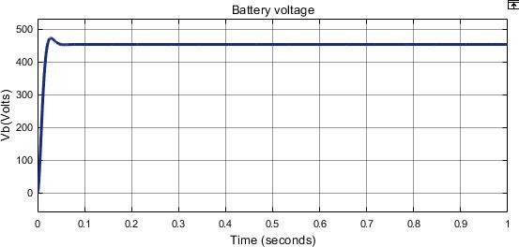

**Voltage**

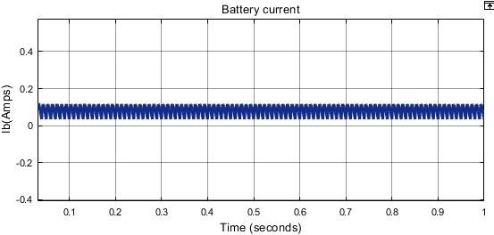

**Current**

**SoC**

**EV Battery voltage, current and state of charge**

**FIGURE 19. (a) Secondary side Converter voltage control (V ss) Current (I ss) (b) Secondary side coil voltage (V ss) across the Receiver Pads (c) Secondary side coil Current (I ss) across the Receiver Pad**

The PFC at the primary side with the control of the secondary end is enhanced in V2G mode of operation. The secondary side measured parameters are represented in Figures 19(a) through 19(c).

Figure 19(a) shows the secondary side converter voltage and current with amplitudes of 310V and 8A. Similarly, the secondary side coil voltage and current are represented in Figures 19(b) and

19(c). The magnitude of the coil voltage and current are 600V and 8A, respectively. The secondary side control in V2G mode of operation shows improved PFC over the primary side control.

**1. THD Values Comparison Table**

|  |  |  |  |  |
| --- | --- | --- | --- | --- |
| **MODES** | **Grid to Vehicle Mode** | | **Vehicle to Grid Mode** | |
| **Controller** | **PSM** | **PSO SMC PSM** | **PSM** | **PSO SMC PSM** |
| Primary side Converter Current | **5.74** | **4.07** | **5.21** | **3.42** |
| Primary side Coil Current | **5.66** | **3.66** | **5.41** | **3.54** |
| Secondary side Converter Current | **5.02** | **3.68** | **14.64** | **7.96** |
| Secondary side Coil Current | **5.14** | **2.86** | **14.38** | **7.04** |

The THD Comparison Table highlights the Total Harmonic Distortion (THD) values for output currents in both Conventional Phase Shift Modulation (PSM) and advanced PSO-SMC-based PSM controllers during Grid-to-Vehicle (G2V) and Vehicle-to-Grid (V2G) modes. Observing the data, it is evident that the PSO-SMC PSM controller consistently achieves lower THD values across all measurement points, including the primary side converter current, primary side coil current, secondary side converter current, and secondary side coil current.

For example, in G2V mode, the primary side converter current THD is reduced from 5.74% (PSM) to 4.07% (PSO-SMC PSM), and the secondary side coil current THD drops significantly from 5.14% (PSM) to 2.86% (PSO-SMC PSM). Similarly, in V2G mode, the PSO-SMC PSM controller demonstrates even greater reductions, with the secondary side coil current THD decreasing from 14.38% (PSM) to 7.04% (PSO-SMC PSM).

## CHAPTER-7

### CONCLUSION

The proposed work offers suitable approach to tackle problems that arise in BWPT systems used in EV charging applications. Beyond the constraints of traditional power factor control methods, the suggested dual-phase shift-regulated PWM methodology provides a sophisticated power factor control strategy designed for two-way operations. A thorough analysis is conducted to support the effectiveness of the suggested system, taking into account factors such as power factor, bifurcation, total harmonic distortion (THD), and power losses. Power transfer efficiencies of 94.4% and 90.1%, respectively, for a 3.7 kW power rating at an 85 kHz operating frequency are demonstrated in simulation and experimental validation tests for G2V and V2G modes. The V2G mode of operation with the dual phase shift control offers the enhanced power factor control without changing the THD and bifurcation factor. Whereas, the G2V mode of operation with the primary control provides the enhancement in the THD and bifurcation. The development of smart and sustainable energy systems depends on improving control mechanisms, as this study emphasizes. It not only makes EV incorporation into smart grids easier, but it also improves BWPT systems’ overall efficiency. In order to support different power ratings and frequencies, future research in BWPT systems concentrate on improving the scalability and adaptability of the suggested dual-phase shift Pulse Width Modulation (PWM) technology. Examining the incorporation of cutting-edge technology, such machine learning or artificial intelligence, may help refine control strategies for better efficiency and performance of the system. Furthermore, investigating the possible incorporation of energy storage systems into the bidirectional power transmission structure may improve the overall dependability and grid stability of the system.

## REFERENCES

1. M. Venkatesan, N. Rajamanickam, P. Vishnuram, M. Bajaj, V. Blazek, L. Prokop, and S. Misak, ‘‘A Review of compensation topologies and control techniques of bidirectional wireless power transfer systems for electric vehicle applications,’’ Energies, vol. 15, no. 20, Oct. 1, 2022, doi: 10.3390/en15207816.
2. Q. He, Q. Luo, K. Ma, P. Sun, and L. Zhou, ‘‘Analysis and design of a single-stage bridgeless high-frequency resonant AC/AC converter,’’ IEEE Trans. Power Electron., vol. 34, no. 1, pp. 700–711, Jan. 2019.
3. M. Kim, D.-M. Joo, and B. K. Lee, ‘‘Design and control of inductive power transfer system for electric vehicles considering wide variation of output voltage and coupling coefficient,’’ IEEE Trans. Power Electron., vol. 34, no. 2, pp. 1197–1208, Feb. 2019, doi: 10.1109/TPEL.2018.2835161.
4. X. Wang, J. Xu, M. Leng, H. Ma, and S. He, ‘‘A hybrid control strategy of LCC-S compensated WPT system for wide output voltage and ZVS range with minimized reactive current,’’ IEEE Trans. Ind. Electron., vol. 68, no. 9, pp. 7908–7920, Sep. 2021, doi: 10.1109/TIE.2020.3013788.
5. X. Qu, H. Chu, S.-C. Wong, and C. K. Tse, ‘‘An IPT battery charger with near unity power factor and load-independent constant output combating design constraints of input voltage and transformer parameters,’’ IEEE Trans. Power Electron., vol. 34, no. 8, pp. 7719–7727, Aug. 2019, doi: 10.1109/TPEL.2018.2881207.
6. X. Liu, N. Jin, X. Yang, K. Hashmi, D. Ma, and H. Tang, ‘‘A novel singleswitch phase controlled wireless power transfer system,’’ Electronics, vol. 7, no. 11, p. 281, Oct. 2018, doi: 10.3390/electronics7110281.
7. V. Shevchenko, O. Husev, R. Strzelecki, B. Pakhaliuk, N. Poliakov, and N. Strzelecka, ‘‘Compensation topologies in IPT systems: Standards, requirements, classification, analysis, comparison and application,’’ IEEE Access, vol. 7, pp. 120559–120580, 2019.